**VISVESVARAYA TECHNOLOGICAL UNIVERSITY**

Jnanasangama, Macche, Santibastwada Road

Belagavi-590018, Karnataka



**Mini Project Work (18EC6ICMPR) Report**

on

**MULTIPLE CITY LOAD SHEDDING SYSTEM**

*Submitted in partial fulfilment of the requirement for the degree of*

**Bachelor of Engineering**

*in*

**Electronics & Communication Engineering**

*By*

1DS18EC090 Spoorthy M K

Under the guidance

Of

**Dr.** Mahesh Kumar N

Mini Project Guide

Designation, ECE Dept., DSCE, Bengaluru



**Department of Electronics & Communication Engineering**

(An Autonomous College affiliated to VTU Belgaum, accredited by NBA & NAAC)

Shavige Malleshwara Hills, Kumaraswamy Layout,

Bengaluru-560078, Karnataka, India

**2020-21**

# Certificate

Certified that the Mini project work entitled “**multiple city load shedding system**” carried out by *Anusha R Sajjanshettar-1DS18EC012, Asaad Ur Raheman Dodamani-1DS18EC014, Meghana S-1DS18EC052, G Chandan-1DS19EC410* is bonafide students of Dayananda Sagar College of Engineering, Bangalore, Karnataka, India in partial fulfilment for the award of Bachelor of Engineering in Electronics & Communication Engineering of the Visvesvaraya Technological University, Belagavi, Karnataka during the academic year 2020-21. It is certified that all corrections / suggestions indicated for Mini project work have been incorporated in the report deposited to the ECE department, the college central library & to the university. This Mini project report **(18EC6ICMPR)** has been approved as it satisfies the academic requirement in respect of project work prescribed for the said degree.

**________________________________ _________________________**

Dept. Project Coordinator Convener Project Guide

Dr. Roopa M Dr. Mahesh Kumar N

**__________________________ ________________________**

Head of the Department Dr. C.P.S. Prakash

Dr. T.C.Manjunath Principal

External Project Viva-Voce

Name of the project examiners:

1 : Signature : _____________________

2 : Signature : _____________________

# Declaration

Certified that the Mini project work entitled, “Multiple city load shedding system” is a bonafide work that was carried out by ourselves in partial fulfilment for the award of degree of Bachelor of Engineering in Electronics & Communication Engg. of the Visvesvaraya Technological University, Belagavi, Karnataka during the academic year 2020-21. We, the students of the Mini project group/batch no. ‘A-1’ hereby declare that the entire Mini project work has been done on our own & we have not copied or duplicated any other’s work. The results embedded in this Mini project work report has not been submitted elsewhere for the award of any type of degree.

Student Name:

1DS18EC012 Anusha R SajjanShettar

1DS18EC014 Asaad Ur Raheman Dodamani

1DS18EC052 Meghana S

1DS19EC410 G Chandan

Sign : _____________________

Date:

Place: Bengaluru -78

**Abstract**

The mini-project work undertaken by us involves the design & development of Multiple cities load shedding system for delivery of power when demand for electricity is greater than the primary power source can supply. Scheduled load shedding is controlled by way of sharing the available electricity among all its customers. By switching off parts of the network in a planned and controlled manner, so the system remains stable throughout the day, and the impact is spread across wider base of customers.

Load shedding schedules are drawn up in advance to describe the plan for switching off parts of the network in sequence during the days that load shedding is necessary. when load shedding is required, the networks are switched off according to the predetermined plan, to ensure that, as far as possible, customers experience load shedding in accordance with well-informed schedules. In exceptional circumstances, if scheduled load shedding is not achieving the required load reduction or an unexpected fault occurs, then System Control Centres will shed load outside the published schedules by using emergency switching in order to protect the network. Such events are rare, but if load shedding is declared, then all customers can expect to be affected at any time, and the planned schedules may not necessarily apply. During load shedding no matter which area, homes and cities are in total blackout. All loads are cut off and we have no means to meet our electricity demands during these times.

Through this project we aim to limit the accessible load. Instead of cutting the entire load during load shedding period, a small portion of load is permitted to be used during the load shed period. We use IoT for a better implementation of this form of load shedding so that there are no complete blackout and people can do their basic needs.

**Table of Contents**

Title sheet 1

Certificate 2

Declaration 3

Abstract 4

Table of contents 5

|  |  |
| --- | --- |
| Chapter 1: Introduction | 6 |
| Chapter 2: Literature survey | 8 |
| Chapter 3: Methodology | 11 |
| Chapter 4: Block diagram and Implementation | 12 |
| Chapter 5: Results and Discussions | 43 |
| Chapter 6: Advantages | 45 |
| Chapter 7: Conclusion and Future work | 45 |
| Chapter 8: Reference | 48 |

**CHAPTER 1:**

**INTRODUCTION**

Electricity has become one of the basic needs of the people. Development and generation of electricity changed the lives drastically, starting from domestic use to industrial activities. Talking about domestic usages there is hardly any task that does not require electricity like cooking, cleaning entertainment, etc. At the industrial and sectors all the technology is dependent on extraordinary creation of man without the discovery of electricity, life wouldn’t be what it is today. Their daily activities, their daily routine, all depends on electricity.

There are several ways to produce electricity and users must have some knowledge of the production of this dependency, but still many countries faces major cries when it comes to electricity with mass power-outages in even major cities. It is our duty to find ways to produce electricity in the most effective manner without making the environment unhealthy and polluted.

In the current scenario of increasing energy demand the utilities are struggling to meet the demand with existing generation. Utilities are forced into load shedding which is an unhealthy practice in the consumer point of view. This project aims to implement a system when there is more demand for power to multiple cities than the available power in the primary power grid.

A load shedding system is used to distribute power from the source grid to everyone by scheduling the supply of power at the possible interval of time to all cities. The system is designed to work flexibly as per the requirement predefined by the human controller in charge. The old fashion complex programable or hard-hand switching technics can now be made easy as simple as a touch-controlled system. The system status can be checked and also can be controlled by a simple GUI from anywhere by connecting through the internet. The system is more reliable as every status of the system is notified to the operator on his mobile phone if he is authorized. By this, we can avoid/reduce visiting the power plant every time.

We use IoT for a better implementation of this form of load shedding so that there is no miscommunication in load shedding. IoT is a developing technology which has high future scopes. With the development of technology, the present IoT technology will flourish. These improvements when applied to our project will increase its functionality.

IoT (Internet of things):

The term Internet of Things generally refers to scenarios where network connectivity and computing capability extends to objects, sensors and everyday items not normally considered computers, allowing these devices to generate, exchange and consume data with minimal human intervention. There is, however, no single, universal definition.

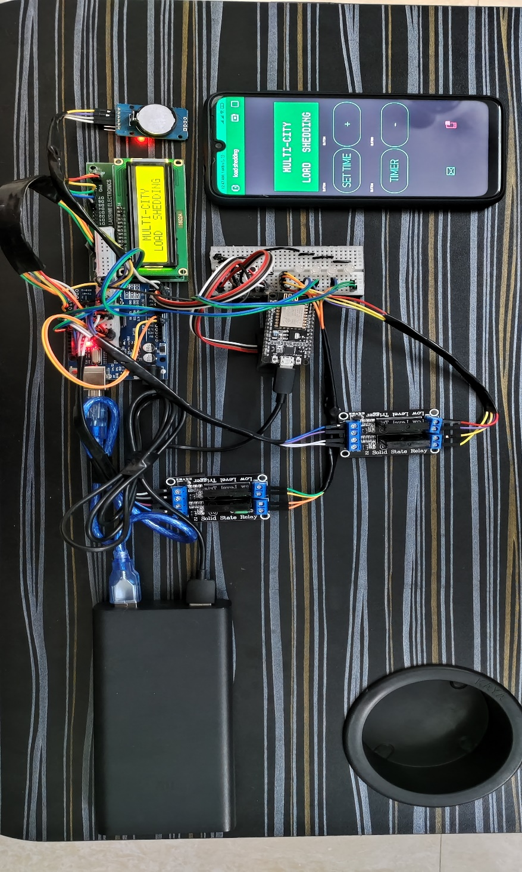 IoT implementations use different technical communications models, each with its own characteristics. Four common communications models described by the Internet Architecture Board include: Device-to-Device, Device-to-Cloud, Device-to-Gateway, and Back-End Data-Sharing. These models highlight the flexibility in the ways that IoT devices can connect and provide value to the user. A [thing](https://internetofthingsagenda.techtarget.com/definition/thing-in-the-Internet-of-Things) in the internet of things can be a person with a heart monitor implant, a farm animal with a [biochip transponder](https://internetofthingsagenda.techtarget.com/definition/injectable-ID-chip-biochip-transponder), an automobile that has built-in [sensors](https://whatis.techtarget.com/definition/sensor) to alert the driver when tire pressure is low or any other natural or man-made object that can be assigned an Internet Protocol (IP) address and is able to transfer data over a network.

**CHAPTER 2:**

**LITERATURE SURVEY**

If load shedding is used efficiently it can help both the utility company and the customer to conserve energy and reduce costs. Delay in load shedding will cost both power and money to the company Industrial machines and home appliances suffer damage due to sudden power fluctuations. Blackouts will result if load shedding is not efficiently performed.

Several dominant blackouts universally caused due to voltage collapse and frequency decline incidents globally. This section of the paper describes some of the blackouts occurred in the recent years

* New York Disturbance [1970]: Tripping of 35MW generator because of over loading on the transmission line resulted in a post contingency voltage decline.
* New Zealand Disturbance [1979]: Tripping of 270 MW causes voltage decline, within 15minutes of the tripping voltage decline to 0.75pu Which results difficulty in synchronization of 70MW gas turbine. Finally using manual load shedding both the systems brought to normal state.
* Tokyo [1987]: The unanticipated sizzling weather condition because of unfavorable characteristics of air conditioners activated the load to pick up at almost 1% per minute and contributed to a major voltage collapse.
* France [1987]: This outage caused by malfunction of protection relay. Voltage collapse occur due to the tripping of many generators by the field current protection relays instead of being field current limited.
* New Delhi [2012]: This outage is considered as a world’s massive outage. Primary facts for this outage are Delicate inter-regional power transmission corridors due to multiple outages. Over loading on 400 kV Bina– Gwalior–Agra link. Lacking corrective actions by State Load Dispatch Centres (SLDCs) to the strategies of Regional Load Dispatch Centres (RLDCs) to cut over drawl by the Northern Region utilities and excess generation by the Western Region utilities. Since there was a miss operation of protection system because of which there was a Loss of 400 kV Bina–Gwalior link.
* Arizona-southern California [2011]: On September 8, 2011, cascading outage occurred due to an 11-minute system disturbance occurred in the Pacific Southwest, and approximately 2.7 million customers left without power.
* U.S.-Canada [2003]: It affected North-eastern United States and parts of southern Canada, from New York north to Toronto and west to Detroit in this blackout, because of the faults instigated by tree contact results in sequential hasty tripping of three main transmission line which results in rapid succession of severe power swings, and voltage and frequency oscillations that caused blackout. Failure of automated method to alert power system operators and technical support personnel before they take appreciated corrective actions.

With the survey of the major black-outs we can conclude that When the frequency/Voltage goes down in a distribution system, it should be brought back near to the reference by shedding a number of loads using UFLS/UVLS. In last decade many outage reported is because of voltage decline rather than frequency. So from last few years UVLS gain main attention in power system security

Our project attempts to create a better load shedding control system through IOT. The load shedding schedule and system status is updated on the internet and can be controlled by any authorized person through a GUI. The load is shed on proper schedules automatically reducing any human errors.

**RELATED PAPERS:**

This section discusses the most recent studies being done in the area of Load shedding framework in the power system.

* M. Karimi H. Mohamad [14] in their study have exhibited the approach of UFLS scheme to solve the stability and underfrequency issue for an islanded system in a distribution network is presented. This approach has implemented the using adaptive and intelligent scheme for two approaches firstly response based which is on the power imbalance whilst and second event based using swing equation based on the frequency and ROCOF measurement. The scheme achieves to instantly perform the load shedding in a single step and intelligently distinguish between the event and response-based condition.
* The study presented by Tamer Adanir [15] has evaluated an approach to under frequency protection in power systems. In this approach, the system frequency is calculated one second advance into the future using a dynamic estimator. Comparing with ordinary under frequency protection relay the proposed algorithm is to provide a smooth and proactive load.
* R. Mageshvaran et al. [16] has used the glow worm Swarm optimization (GSO) algorithm which is inspired by nature activity. The optimization of load shedding is accomplished by squaring the difference between active and reactive power. This approach gives a better voltage profile, more supplied power and better convergence characteristics compare to the conventional method.
* Manson et al. [17] have presented a study for under-frequency load shedding by proper coordination between protective relays. The author of this method modelled the power system using inertial and load tracking mechanism. This method gives a better outcome for several contingencies.
* Mokari et al. [18] proposed an adaptive technique in which load to be shed is prioritized. In this method, multiple loads can be shed based on the severity of the disturbance.

## **EXISTING SYSTEM:**

The present Load shedding system is of the conventional one. The system needs continuous human monitoring and manual switching of the load. This kind of system is outdated and exhausting, such system always results in improper load shedding, inappropriate system management, and even blackouts. Most of the power-cuts and black-outs that occur in our country are due to such reasons. Even during these days, it has become more difficult to carry load shedding and operation manually due to the pandemic situations. Hence to avoid such scenarios a system must be established which can help manage Load Shedding without human effort and that can be operated remotely.

**CHAPTER 3:**

**METHODOLOGY**

* Checking whether station have enough power or not if yes then distribute the equal and fulltime power to all cities without any interruption.
* The power customers experience interrupted power supply when electrical power generation lowers or stops electricity distribution across the cities when customer’s demand is greater than available capacity, so the sudden shutdown of the power can be reduced by proper planned supply of available capacity among all the cities.
* Power suppliers should schedule the available electricity with fairly distribution to all cities with their demand by RTC module with the help of keypad or can operate through the Blynk app.
* Update the scheduled power distribution to all the cities and also update in Blynk,
* If any interruption occurs due to less power generation or for any reasons then the power distributors will aware of power consumption and distribute the power to all cities with their demands.
* By this we can stop the disagreement or quarrel among interconnected villages caused due to unfair supply of power.
* Through this we can handle the sudden emergency situations where power supply is necessary without any delay as they can handle it from anywhere.
* By this we can maintain friendly relationship between public and power supply station as they will be aware of functions of power supply through Blynk.

**CHAPTER 4:**

**BLOCK DIAGRAM AND IMPLEMENTATION**



**Block diagram description:**

The brief block diagram is as shown in the figure. This is the automatic operating system, the user has to give the inputs like the date, time and loads to the system, and all this set by the system to communicate through GUI, and the controller also sends the status of the system to the users. The complete information of the system is fed to the Arduino UNO for data processing for the program in Arduino. This is the open-source microcontroller, this board has inbuilt LED and power handling, the Arduino projects can stand alone or they can be connected to a computer using USB.

The input devices which we are giving to the Arduino processer are keypad, RTC and Node MCU ESP8266.

Through the RTC (Real time clock) module the user will set the date and time using keypad or push buttons.

To set date, time and to enable and disable the loads of each city, we use push buttons.

The required internet facility for Arduino is provided by the Node MCU ESP8266 and it is connected to cloud and connected to graphical user interface (GUI), in our project the Blynk app acts as GUI.

The output devices connected to the Arduino processer are display, buzzer, led, and loads. The led and buzzer perform the function of giving signal to the user that is the led will give the signal by blinking on and off when the power shifts from one city to another city or when any interruption occur in middle. The buzzer is also doing almost the same function as it gives signal by beeping when the power shifts from one city to another city or when any interruption occur in middle.

To display or to view the updates and scheduled date, time and load setting of each cities, we use 16x2 bit LCD (liquid crystal display).

We consider the loads as a city in our project and connect these loads with relay to switch the power from one city to another city.

**HARDWARE AND SOFTWARE REQUIREMENTS**:

* HARDWARE REQUIRED
  + Arduino UNO
  + node MCU ESP8266
  + RTC module
  + LED
  + Buzzer
  + LCD
  + Relay
  + Push buttons
* SOFTWARE REQUIRED
* Proteus 8 software
* Blynk (GUI)

1. **ARDUINO UNO:**

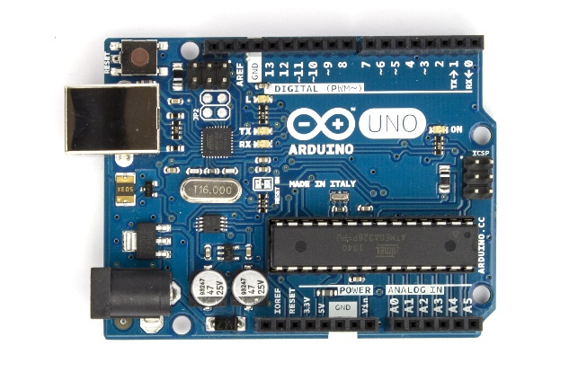

The Arduino Uno is a microcontroller board based on the ATmega328 (datasheet). 5Volts regulated power supply used to power microcontroller, and 3.3Volts supply generated by onboard voltage regulator. Maximum current draw is 50mA. AREF is used to provide reference voltage for input voltage. It is a 16 MHz crystal oscillator, a USB connection, a power jack, an ICSP header, and a reset button. It contains everything needed to support the microcontroller; simply connect it to a computer with a USB cable or power it with an AC-to-DC adapter or battery to get started. The Uno differs from all preceding boards in that it does not use the FTDI USB-to-serial driver chip. Instead, it features the Atmega8U2 programmed as a USB-to-serial converter.

"Uno" means one in Italian and is named to mark the upcoming release of Arduino 1.0. The Uno and version 1.0 will be the reference versions of Arduino, moving forward. The Uno is the latest in a series of USB Arduino boards, and the reference model for the Arduino platform; for a comparison with previous versions

* The ATmega328 on the board comes pre-programmed with a bootloader that allows uploading new code to it without the use of an external hardware programmer.
* The analog pins can serve as analog inputs but can also function as digital inputs or digital outputs, these pins accept input in the form of analog signals and return values that range between 0 and 1023.

### **Arduino UNO Specifications & Features:**

* Microcontroller: ATmega328
* Operating Voltage: 5V
* Input Voltage (recommended): 7-12V
* Input Voltage (limits): 6-20V
* Digital I/O Pins: 14 (of which 6 provide PWM output)
* Analog Input Pins: 6
* DC Current per I/O Pin: 40 mA
* DC Current for 3.3V Pin: 50 mA
* Flash Memory: 32 KB of which 0.5 KB used by bootloader
* SRAM: 2 KB
* EEPROM: 1 KB
* Clock Speed: 16 MHz

**Pin configuration:**

* The board contains14 digital input/output pins (of which 6 can be used as PWM outputs), 6 analog inputs.
* Power pins are:
* VIN: The input voltage to the Arduino board when it's using an external power source. You can supply voltage through this pin, or, if supplying voltage via the power jack, access it through this pin.
* 5V: The regulated power supply used to power the microcontroller and other components on the board. This can come either from VIN via an on-board regulator, or be supplied by USB or another regulated 5V supply.
* 3V3: A 3.3volt supply generated by the on-board regulator. Maximum current draw is 50 mA.
* GND: Ground pins.
* 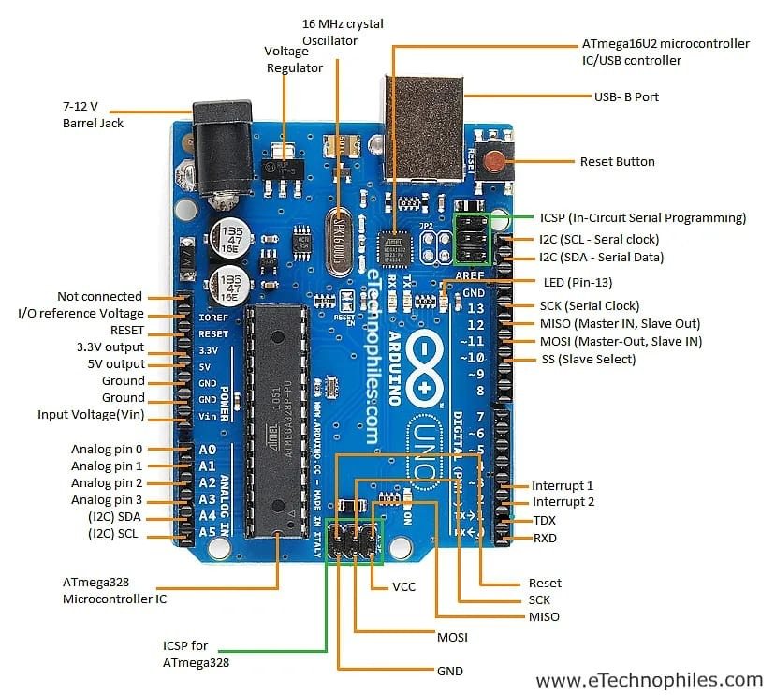 Serial: 0 (RX) and 1 (TX). Used to receive (RX) and transmit (TX) TTL serial data.
* PWM: 3, 5, 6, 9, 10, and 11. Provide 8-bit PWM output with the analogWrite() function.
* SPI: 10 (SS), 11 (MOSI), 12 (MISO), 13 (SCK). These pins support SPI communication, which, although provided by the underlying hardware, is not currently included in the Arduino language.
* LED: 13. There is a built-in LED connected to digital pin 13. When the pin is HIGH value, the LED is on, when the pin is LOW, it's off.
* The Arduino boards have feature other hardware I/O and communication interfaces, such as SPI communication using the SPI library, I2C/Two Wire Interface (I2C/TWI) communications using the wire library, and UART communication, In-Circuit Serial Programming (ICSP) header.
* SCL stands for serial clock that transfers the clock data, SDA stands for serial data used by the slave and master to send and receive the data,
* It can be powered by the USB cable or by an external 9volt battery, through it accepts voltage voltages between 7 and 20 volts.

1. **NODE MCU:**

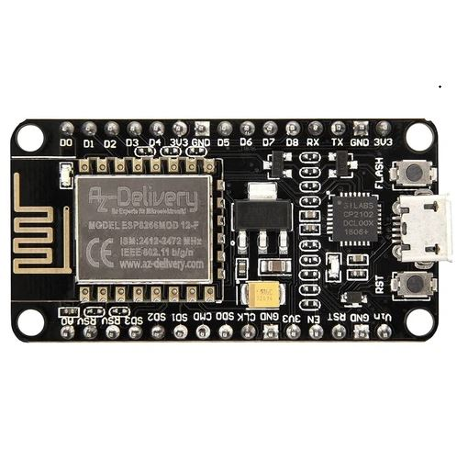

* The Node MCU ESP8266 development board comes with the ESP-12E module containing ESP8266 chip having Tensilica Xtensa 32-bit LX106 RISC microprocessor.
* Regulated 3.3V can be supplied to this pin to power the board.
* Node MCU has 16 general purpose I/o pins and four pins available for SPI communication.
* This microprocessor supports RTOS and operates at 80MHz to 160 MHz adjustable clock frequency.
* It has 128 KB RAM to store data and programs
* USB-TTL based on CP2102 is included onboard,
* It supports UART, SPI, and I2C interface**.**
* Most of the IoT devices have to be connected to the internet through Wi-Fi SSID and password in our program and make it work.
* It as an inbuilt LED that is configured as pin number BUILTIN_LED, LED_BUILTIN, LED, 2, 16, D0, D4.
* Library which we are using here is ESP8266 WIFI library, to give the internet connectivity to Arduino board.

### **Node MCU ESP8266 Specifications & Features:**

* Microcontroller: Ten silica 32-bit RISC CPU Extensa LX106
* Operating Voltage: 3.3V
* Input Voltage: 7-12V
* Digital I/O Pins (DIO): 16
* Analog Input Pins (ADC): 1
* UARTs: 1
* SPIs: 1
* Flash Memory: 4 MB
* SRAM: 64 KB
* Clock Speed: 80 MHz
* USB-TTL based on CP2102 is included onboard, Enabling Plug n Play
* PCB Antenna
* Small Sized module to fit smartly inside your IoT projects.

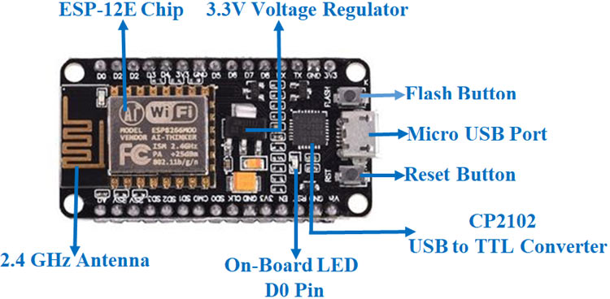**Node MCU Pinout Configuration:**

|  |  |  |
| --- | --- | --- |
| Pin category | Name | Description |
| Power | Micro-USB:  GND:  Vin: | Regulated 3.3V can be supplied to this pin to power the board.  Ground pins.  External Power Supply. |
| Control Pins | EN, RST | The pin and the button reset the microcontroller. |
| Analog Pins | A0 | Used to measure analog voltage in the range of 0-3.3V. |
| GPIO Pins | GPIO1 to GPIO16 | Node MCU has 16 general purpose input-output pins on its board. |
| SPI Pins | SD1, CMD, SD0, CLK | Node MCU has four pins available for SPI communication. |
| UART Pins | TXD0, RXD0, TXD2, RXD2 | Node MCU has two UART interfaces, UART0 (RXD0 & TXD0) and UART1 (RXD1 & TXD1). UART1 is used to upload the firmware/program. |
| I2C Pins |  | Node MCU has I2C functionality support but due to the internal functionality of these pins, you have to find which pin is I2C. |

1. 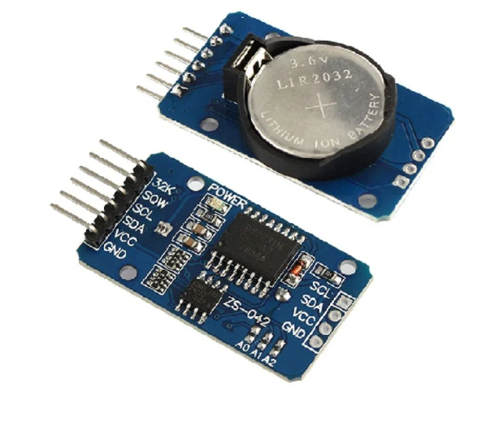**RTC:**

#### RTC is a simple two-wire I2C interface which can be easily interfaced with any microcontroller. It is generally used in computers, laptops, mobiles, embedded system applications devices etc.

#### In many embedded systems, we need to put time stamp while logging data i.e., sensor values, GPS coordinates etc. For getting timestamp, we need to use RTC.

* It manages all timekeeping functions and features a simple two-wire I2C interface which can be easily interfaced with any microcontroller of your choice.
* the chip maintains seconds, minutes, hours, day, date, month and year information.
* The date at the end of the month is automatically adjusted for months with fewer than 31 days, including corrections for leap year.
* The clock operates in either the 24-hour or 12-hour format with AM/PM indicator.

**Specifications and features:**

#### Operating voltage: 2.3V – 5.5V

#### Maximum voltage at SDA , SCL: VCC + 0.3V

#### Operating temperature: -45ºC to +80ºC

#### Can operate on LOW voltages and consumes 500nA on battery backup.

#### The SQW pin gives outputs one of four square-wave frequencies 1Hz, 4kHz, 8kHz or 32kHz and can be enabled programmatically.

#### The built-in power-sensor circuit continuously monitors the status of VCC to detect power failures and automatically switches to the backup supply.

#### The bottom side of the board holds a battery holder for 20mm 3V lithium coin cells. Any CR2032 battery can fit well.

#### DS3231 RTC module also comes with a 32 bytes 24C32 EEPROM chip from Atmel having limited read-write cycles.

#### The 24C32 EEPROM uses I2C interface for communication and shares the same I2C bus as DS3231.

#### Pin configuration:

* DS3231 is a six-terminal device, out of them two pins are not compulsory to use. So, we have mainly four pins. These four pins are given out on other side of module sharing the same name.
* Connect 3 Volt CMOS battery to V(bat) pin. RTC DS1307 has inbuilt mechanism to detect 5volt VCC, if external 5volt VCC is not there, then it takes the supply from 3volt CMOS battery.

#### The remaining pins that are used for I2C communication, on the Arduino boards with the R3 layout.

#### the SDA (data line) and SCL (clock line) are on the pin headers close to the AREF pin they also known as A5 (SCL) and A4 (SDA).

#### The code of this controller includes the RTClib.h libraries for communicating with the module.

#### LED:

#### The LEDs you are most likely to use are the **through hole** LEDs with two wires. One wire is the **anode** (positive) and another is the **cathode**(negative). The two wires have different names because LEDs only work in one direction and we need to keep track of which pin is which. One goes to the positive voltage and the other goes to the negative voltage. Electronic parts that only work in 'one direction' like this are called ****Diodes****.

* The longer lead goes to the more-positive voltage
* Current goes in one direction, from the anode (positive) to the cathode (negative).

#### A semiconductor diode which glows when a voltage is applied. Stands for light emitting diode.

#### Made popular by their efficiency, range of color, and long lifespan, LED lights are ideals for numerous applications, these lights are also commonly used in electronics and automotive industries.

#### BUZZER:

#### A buzzer or beeper is an audio signalling device, which may be mechanical, electromechanical or piezoelectric. The buzzer is a sounding device that can convert audio signals into sound signals. It is usually powered by DC voltage.

#### it is mainly divided into piezoelectric buzzer and electromagnetic buzzer according to different designs and uses and it can emit various sounds.

#### There are two types are buzzers that are commonly available. The simple buzzer which when powered will make a Continuous Beeeeeeppp.... sound, the other type is called a readymade buzzer which will look bulkier than this and will produce a Beep. Beep. Beep. Sound due to the internal oscillating circuit present inside it.

### **Features and Specifications:**

* Rated Voltage: 6V DC
* Operating Voltage: 4-8V DC
* Rated current: <30mA
* Sound Type: Continuous Beep
* Resonant Frequency: ~2300 Hz
* Small and neat sealed package
* Breadboard and Perf board friendly

#### Pin configuration:

#### Pin1: positive - Identified by (+) symbol or longer terminal lead. Can be powered by 6V DC.

#### Pin2: negative - identified by short terminal lead. Typically connected to the ground of the circuit.

#### LCD:

#### Liquid Crystal Display is a type of flat panel display which uses liquid crystals in its primary form of operation. LCD uses a liquid crystal to produce a visible image. Liquid crystal displays are super-thin technology display screens.

* The 16×2 LCD display is a very basic module commonly used in DIYs and circuits. The 16×2 translates a display 16 characters per line in 2 such lines. In this LCD each character is displayed in a 5×7pixel matrix.

#### LEDs have a large and varying set of use cases for consumers and businesses, as they can be commonly found in smartphones, televisions, computer monitors and instrument panels.

#### Features and specifications:

* Operating Voltage is 4.7V to 5.3V
* Current consumption is 1mA without backlight
* Alphanumeric LCD display module, meaning can display alphabets and numbers
* Consists of two rows and each row can print 16 characters.
* Each character is built by a (5×8)-pixel box
* Can work on both 8-bit and 4-bit mode
* It can also display any custom generated characters
* Available in Green and Blue Backlight

#### Pin configuration:

#### LCD interfacing with MSP430 LaunchPadwith examples

|  |  |
| --- | --- |
| Pin name | Description |
| Vss (Ground) | Ground pin connected to system ground |
| Vdd (+5 volts) | Powers the LCD with +5V (4.7V – 5.3V) |
| VE (Constant V) | Decides the contrast level of display. Grounded to get maximum contrast. |
| Register Select | Connected to Microcontroller to shift between command/data register |
| Read/Write | Used to read or write data. Normally grounded to write data to LCD |
| Enable | Connected to Microcontroller Pin and toggled between 1 and 0 for data acknowledgement |
| Data pin 0 to 7 | Data pins 0 to 7 forms an 8-bit data line. They can be connected to Microcontroller to send 8-bit data.  These LCD’s can also operate on 4-bit mode in such case Data pin 4,5,6 and 7 will be left free. |
| LED Positive | Backlight LED pin positive terminal |
| LED Negative | Backlight LED pin negative terminal |

#### RELAY:

#### Relay is an electrically operated switch as shown in Figure 3.8.1. Many relays use an electromagnet to mechanically operate a switch, but other operating principles are also used, such as solid-state relays. Relays are used where it is necessary to control a circuit by a separate low-power signal, or where several circuits must be controlled by one signal. A type of relay that can handle the high power required to directly control an electric motor or other loads is called a contactor. Solid-state relays control power circuits with no moving parts, instead using a semiconductor device to perform switching. Relays with calibrated operating characteristics and sometimes multiple operating coils are used to protect electrical circuits from overload or faults; in modern electric power systems these functions are performed by digital instruments still called "protective relays". A relay is used to switch on a high-powered circuit with a small current.

#### 

#### The logical circuit of the operation of relay is as shown in the Figure 3.8.2. The relay will act as either Normally Open (NO) switch or Normally Closed switch. The tolerance of the relay that we are using is ~230V.

#### PROTEUS 8 SOFTWARE:

#### Proteus Design Suite - Wikipedia

The Proteus Design Suite is widely used across various industry sectors as a cost-effective solution for professional PCB design and as a rapid prototyping tool for R&D. Virtual Prototyping enables system Testing before the first physical PCB is ordered. Shape based auto routing as standard saves time with non-critical routing. Direct access to over 15 million parts means never building a component or footprint again.

Proteus is a work management automation platform designed from the ground-up by diversified energy industry professionals to help the industry digitally transform and transition to a low carbon future. It brings together talent acquisition, project management and finance into one cloud-based hub. A powerful engine of integration for your business which brings data from third party software like Microsoft 365, Google Workspaces and ERP to provide real-time project oversight, powering accurate, consistent work and driving operational efficiency and increased profitability:

#### Proteus 8 professional is a software which can be used to draw schematics, PCB layout, code and even simulate the schematic.

#### Proteus is a single integrated application with ISIS, ARES and 3D Viewer modules appearing as tabbed modules.

#### Proteus stores the design (DSN), layout (LYT) and common database in a single project file (PDSPRJ).

#### It is developed by Lab center Electronic Ltd.

#### There are two options for simulating:

#### Run simulator

#### advance frame by frame.

#### The Run simulator option simulates the circuit in a normal speed (If the circuit is not heavy).

#### Advance frame by frame option advances to next frame and waits till you click this button for the next time.

**IMPLEMENTATION:**

The project is an automatic load operation system that controls load operation, multiple numbers of times according to programmed instruction. The project eliminates the manual ON/OFF switching of load. A real time clock (RTC) is used to track the time and automatically switch ON/OFF the load.

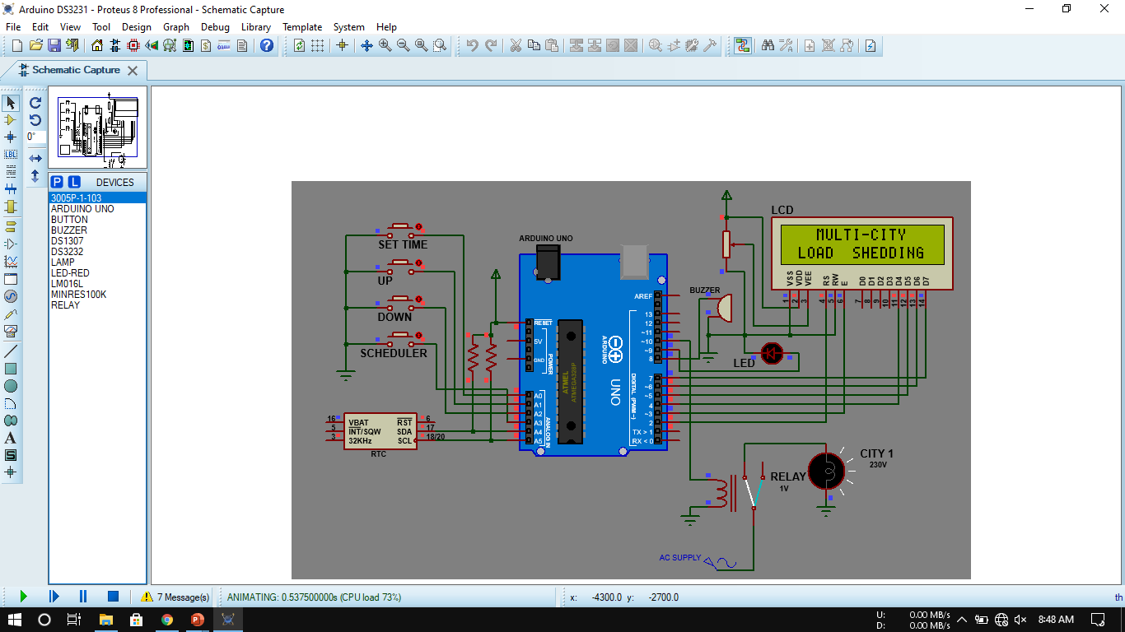0This project is required for load shedding time management which is used when the electricity demand exceeds the supply and there comes a need for manually switching ON/OFF the electrical devices in time. Hence this system eliminates the manual operation by automatically switching the load ON/OFF. A matrix keypad is interfaced with the microcontroller from where the specified time is input to the microcontroller.

When this input time equals to the real time, based on the commands the microcontroller initiates that particular relay to switch ON/OFF the load. The time is displayed on a seven-segment display.

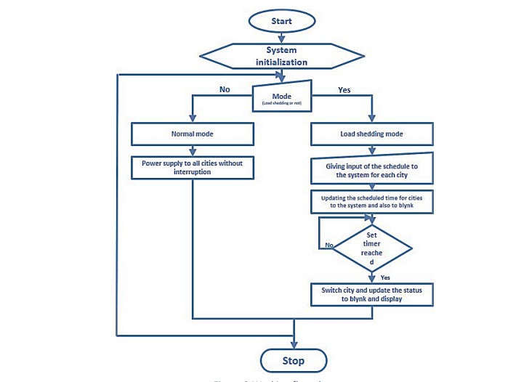

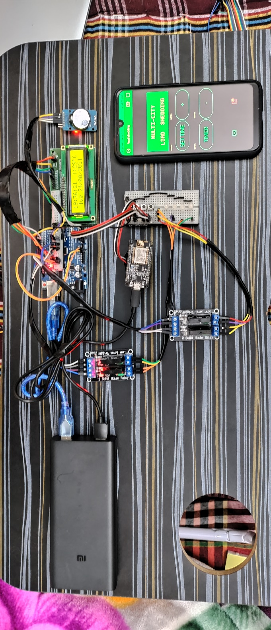The working of this system requires a Real Time Clock (RTC) to monitor time continuously, an LCD Display to display the set date and time, three relays for switching Loads, a web server connection to control Shedding operation through the web, a keypad to enter a set ON/OFF time and date. And to control all the processes we use an Arduino UNO R3 microcontroller.

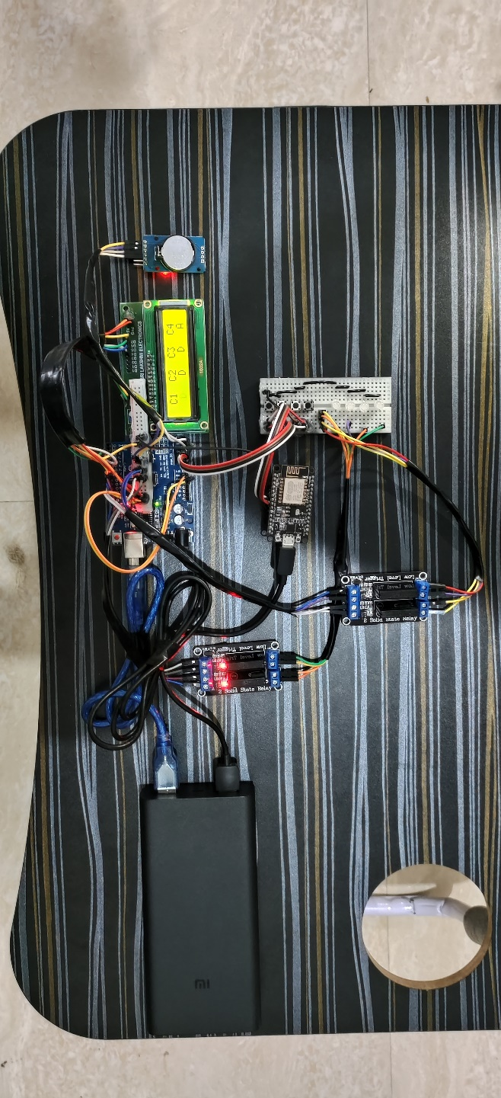First the system is turned online and the microcontroller is initialized. After initialization the working mode of the system is selected. The system operates in two modes- Normal mode and Load Shedding Mode. Under Normal mode the power supply is provided to all cities without interruption. If Load Shedding is required the system switches to Load Shedding mode. In Load Shedding mode the Time of Load Shedding is pre-set into the system through an internet web server by an authorized operator. The same is updated on an official social media handle. After the schedule for each city is set to the specified time and date the final update is done and the system begins to operate the Shedding. Each time the set time for a city is reached the controller switches the power supply between different cities through a set of relays. After enough Load Shedding the system can be reset and can operate on Normal mode.

**PROGRAM:**

**#**include <DS3231.h>//Memanggil RTC3231 Library

#include <Wire.h> // i2C Conection Library

#include <LiquidCrystal.h> //Libraries

#include <EEPROM.h>

LiquidCrystal lcd(2, 3, 4, 5, 6, 7); //Arduino pins to lcd

#define bt_clock A0

#define bt_up A1

#define bt_down A2

#define bt_timer A3

#define relay1 8

#define relay2 9

#define relay3 10

#define relay4 11

#define buzzer 13

// Init DS3231

DS3231 rtc(SDA, SCL);

// Init a Time-data structure

Time t; //pencacah string time()

int hh = 0, mm = 0, ss = 0, dd = 0, bb = 0, set_day;

int yy = 0;

String Day = " ";

int StartHH = 0, StartMM = 0, FinishHH = 0, FinishMM = 0, setMode = 0, setAlarm = 0, alarmMode=1;

int Start1HH, Start1MM, Finish1HH, Finish1MM;

int Start2HH, Start2MM, Finish2HH, Finish2MM;

int Start3HH, Start3MM, Finish3HH, Finish3MM;

int Start4HH, Start4MM, Finish4HH, Finish4MM;

int timer1, timer2, timer3, timer4;

int stop =0, mode=0, flag=0;

void setup(){

rtc.begin(); // memulai koneksi i2c dengan RTC

pinMode(bt_clock, INPUT_PULLUP);

pinMode(bt_up, INPUT_PULLUP);

pinMode(bt_down, INPUT_PULLUP);

pinMode(bt_timer, INPUT_PULLUP);

pinMode(relay1, OUTPUT);

pinMode(relay2, OUTPUT);

pinMode(relay3, OUTPUT);

pinMode(relay4, OUTPUT);

pinMode(buzzer, OUTPUT);

lcd.begin(16, 2); // Configura lcd numero columnas y filas

lcd.setCursor(0,0); //Show "TIME" on the LCD

lcd.setCursor (3,0);

lcd.print("MULTI-CITY");

lcd.setCursor (1,1);

lcd.print("LOAD SHEDDING");

delay (2000);

lcd.clear();

stop=EEPROM.read(50);

if(stop==0){

}else{

mode=1;WriteEeprom ();delay (20);

mode=2;WriteEeprom ();delay (20);

mode=3;WriteEeprom ();delay (20);

mode=4;WriteEeprom ();delay (20);

mode=0;

}

EEPROM.write(50,0);

ReadEeprom();

//Set RTC Untuk Pertama kali

//rtc.setDOW(2); // Set Day-of-Week to SUNDAY

//rtc.setTime (00, 9, 50);

//rtc.setDate(12, 11, 2017);

}

void loop(){

t = rtc.getTime();

Day = rtc.getDOWStr(1);

if (setMode == 0){

hh = t.hour,DEC;

mm = t.min,DEC;

ss = t.sec,DEC;

dd = t.date,DEC;

bb = t.mon,DEC;

yy = t.year,DEC;

//if(t.hour>12){hh=t.hour-12;}// for removing 24 houre

//else{hh=t.hour;}

}

if(setAlarm==0){

lcd.setCursor(0,0);

lcd.print((hh/10)%10);

lcd.print(hh % 10);

lcd.print(":");

lcd.print((mm/10)%10);

lcd.print(mm % 10);

lcd.print(":");

lcd.print((ss/10)%10);

lcd.print(ss % 10);

lcd.print(" T:");

lcd.print(rtc.getTemp(),0);

lcd.write(223);

lcd.print("C");

lcd.print(" ");

lcd.setCursor(1,1);

lcd.print(Day);

lcd.print(" ");

lcd.print((dd/10)%10);

lcd.print(dd % 10);

lcd.print("/");

lcd.print((bb/10)%10);

lcd.print(bb % 10);

lcd.print("/");

lcd.print((yy/1000)%10);

lcd.print((yy/100)%10);

lcd.print((yy/10)%10);

lcd.print(yy % 10);

}

setupClock();

setTimer();

delay (100);

blinking();

//Timer1 ON

if (timer1==1 && alarmMode==1 && hh==Start1HH && mm==Start1MM) {digitalWrite(relay1, HIGH); }

//Timer1 OFF

if (timer1==1 && alarmMode==1 && hh==Finish1HH && mm==Finish1MM){digitalWrite(relay1, LOW);}

//Timer2 ON

if (timer2==1 && alarmMode==1 && hh==Start2HH && mm==Start2MM) {digitalWrite(relay2, HIGH);}

//Timer2 OFF

if (timer2==1 && alarmMode==1 && hh==Finish2HH && mm==Finish2MM){digitalWrite(relay2, LOW);}

//Timer3 ON

if (timer3==1 && alarmMode==1 && hh==Start3HH && mm==Start3MM) {digitalWrite(relay3, HIGH);}

//Timer3 OFF

if (timer3==1 && alarmMode==1 && hh==Finish3HH && mm==Finish3MM){digitalWrite(relay3, LOW);}

//Timer4 ON

if (timer4==1 && alarmMode==1 && hh==Start4HH && mm==Start4MM) {digitalWrite(relay4, HIGH);}

//Timer4 OFF

if (timer4==1 && alarmMode==1 && hh==Finish4HH && mm==Finish4MM){digitalWrite(relay4, LOW);}

delay (100);

digitalWrite(buzzer, LOW);

}

void blinking (){

//BLINKING SCREEN

//Set Clock

if (setAlarm <2 && setMode == 1){lcd.setCursor(0,0); lcd.print(" ");}

if (setAlarm <2 && setMode == 2){lcd.setCursor(3,0); lcd.print(" ");}

if (setAlarm <2 && setMode == 3){lcd.setCursor(6,0); lcd.print(" ");}

if (setAlarm <2 && setMode == 4){lcd.setCursor(1,1); lcd.print(" ");}

if (setAlarm <2 && setMode == 5){lcd.setCursor(5,1); lcd.print(" ");}

if (setAlarm <2 && setMode == 6){lcd.setCursor(8,1); lcd.print(" ");}

if (setAlarm <2 && setMode == 7){lcd.setCursor(11,1); lcd.print(" "); }

//Set Timer

if (setMode == 0 && setAlarm == 1 && mode==0){lcd.setCursor(2,1); lcd.print(" "); }

if (setMode == 0 && setAlarm == 2 && mode==0){lcd.setCursor(6,1); lcd.print(" "); }

if (setMode == 0 && setAlarm == 3 && mode==0){lcd.setCursor(10,1); lcd.print(" "); }

if (setMode == 0 && setAlarm == 4 && mode==0){lcd.setCursor(13,1); lcd.print(" "); }

if (setMode == 0 && setAlarm == 1 && mode>0){lcd.setCursor(11,0); lcd.print(" "); }

if (setMode == 0 && setAlarm == 2 && mode>0){lcd.setCursor(14,0); lcd.print(" "); }

if (setMode == 0 && setAlarm == 3 && mode>0){lcd.setCursor(11,1); lcd.print(" "); }

if (setMode == 0 && setAlarm == 4 && mode>0){lcd.setCursor(14,1); lcd.print(" "); }

}

//Seting Jam ,Tanggal,Alarm/Timer

void setupClock (void) {

if (setMode == 8){

lcd.setCursor (0,0);

lcd.print ("Set Time Finish ");

lcd.setCursor (0,1);

lcd.print ("Set Date Finish ");

delay (1000);

rtc.setTime (hh, mm, ss);

rtc.setDate (dd, bb, yy);

lcd.clear();

setMode = 0;

}

if (setAlarm >0){alarmMode=0;}

if(digitalRead (bt_clock) == 0 && flag==0) {flag=1;

if(setAlarm>0){WriteEeprom(); setAlarm=1; mode =5;}

else{setMode = setMode+1;}

digitalWrite(buzzer, HIGH);

}

if(digitalRead (bt_timer) == 0 && flag==0){flag=1;

if(setMode>0){setMode=8;}

else{

setAlarm = setAlarm+1;

if(setAlarm>4){setAlarm=1;

WriteEeprom ();

mode=mode+1;

ReadEeprom();

}

}

lcd.clear();

digitalWrite(buzzer, HIGH);

}

if(setAlarm == 1 && mode==5){

lcd.setCursor (0,0);

lcd.print ("Set Timer Finish");

lcd.setCursor (0,1);

lcd.print ("-EEPROM Updated-");

delay (2000);

lcd.clear();

setAlarm=0;

mode =0;

alarmMode=1;

}

if(digitalRead (bt_clock) == 1 && digitalRead (bt_timer) == 1){flag=0;}

if(digitalRead (bt_up) == 0){

if (setAlarm<2 && setMode==1)hh=hh+1;

if (setAlarm<2 && setMode==2)mm=mm+1;

if (setAlarm<2 && setMode==3)ss=ss+1;

if (setAlarm<2 && setMode==4)set_day=set_day+1;

if (setAlarm<2 && setMode==5)dd=dd+1;

if (setAlarm<2 && setMode==6)bb=bb+1;

if (setAlarm<2 && setMode==7)yy=yy+1;

//Timer

if (mode==0 && setMode==0 && setAlarm==1)timer1=1;

if (mode==0 && setMode==0 && setAlarm==2)timer2=1;

if (mode==0 && setMode==0 && setAlarm==3)timer3=1;

if (mode==0 && setMode==0 && setAlarm==4)timer4=1;

if (mode>0 && setMode==0 && setAlarm==1)StartHH=StartHH+1;

if (mode>0 && setMode==0 && setAlarm==2)StartMM=StartMM+1;

if (mode>0 && setMode==0 && setAlarm==3)FinishHH=FinishHH+1;

if (mode>0 && setMode==0 && setAlarm==4)FinishMM=FinishMM+1;

if(hh>23)hh=0;

if(mm>59)mm=0;

if(ss>59)ss=0;

if(set_day>7)set_day=0;

if(dd>31)dd=0;

if(bb>12)bb=0;

if(yy>2030)yy=2000;

if(StartHH>23)StartHH=0;

if(StartMM>59)StartMM=0;

if(FinishHH>23)FinishHH=0;

if(FinishMM>59)FinishMM=0;

rtc.setDOW(set_day);

digitalWrite(buzzer, HIGH);

}

if(digitalRead (bt_down) == 0){

if (setAlarm<2 && setMode==1)hh=hh-1;

if (setAlarm<2 && setMode==2)mm=mm-1;

if (setAlarm<2 && setMode==3)ss=ss-1;

if (setAlarm<2 && setMode==4)set_day=set_day-1;

if (setAlarm<2 && setMode==5)dd=dd-1;

if (setAlarm<2 && setMode==6)bb=bb-1;

if (setAlarm<2 && setMode==7)yy=yy-1;

//Timer

if (mode==0 && setMode==0 && setAlarm==1)timer1=0;

if (mode==0 && setMode==0 && setAlarm==2)timer2=0;

if (mode==0 && setMode==0 && setAlarm==3)timer3=0;

if (mode==0 && setMode==0 && setAlarm==4)timer4=0;

if (mode>0 && setMode==0 && setAlarm==1)StartHH=StartHH-1;

if (mode>0 && setMode==0 && setAlarm==2)StartMM=StartMM-1;

if (mode>0 && setMode==0 && setAlarm==3)FinishHH=FinishHH-1;

if (mode>0 && setMode==0 && setAlarm==4)FinishMM=FinishMM-1;

if(hh<0)hh=23;

if(mm<0)mm=59;

if(ss<0)ss=59;

if(set_day<0)set_day=7;

if(dd<0)dd=31;

if(bb<0)bb=12;

if(yy<0)yy=2030;

if(StartHH<0)StartHH=23;

if(StartMM<0)StartMM=59;

if(FinishHH<0)FinishHH=23;

if(FinishMM<0)FinishMM=59;

rtc.setDOW(set_day);

digitalWrite(buzzer, HIGH);

}

}

void setTimer (){

//Timer

if (setMode == 0 && setAlarm >0 && mode>0){

lcd.setCursor (0,0);

lcd.print("Load");

lcd.print(mode);

lcd.print(" On :");

lcd.setCursor (11,0);

lcd.print((StartHH/10)%10);

lcd.print(StartHH % 10);

lcd.print(":");

lcd.print((StartMM/10)%10);

lcd.print(StartMM % 10);

lcd.setCursor (0,1);

lcd.print("Load");

lcd.print(mode);

lcd.print(" Off:");

lcd.setCursor (11,1);

lcd.print((FinishHH/10)%10);

lcd.print(FinishHH % 10);

lcd.print(":");

lcd.print((FinishMM/10)%10);

lcd.print(FinishMM % 10);

}

if (setMode == 0 && setAlarm >0 && mode==0){

lcd.setCursor (0,0);

lcd.print(" C1 C2 C3 C4 ");

lcd.setCursor (0,1);

if(timer1==1){lcd.print(" A");}

else{lcd.print(" D");}

if(timer2==1){lcd.print(" A");}

else{lcd.print(" D");}

if(timer3==1){lcd.print(" A");}

else{lcd.print(" D");}

if(timer4==1){lcd.print(" A");}

else{lcd.print(" D");}

}

}

void ReadEeprom() {

Start1HH=EEPROM.read(11);Start1MM=EEPROM.read(12);Finish1HH=EEPROM.read(13);Finish1MM=EEPROM.read(14);

Start2HH=EEPROM.read(21);Start2MM=EEPROM.read(22);Finish2HH=EEPROM.read(23);Finish2MM=EEPROM.read(24);

Start3HH=EEPROM.read(31);Start3MM=EEPROM.read(32);Finish3HH=EEPROM.read(33);Finish3MM=EEPROM.read(34);

Start4HH=EEPROM.read(41);Start4MM=EEPROM.read(42);Finish4HH=EEPROM.read(43);Finish4MM=EEPROM.read(44);

if(mode==1){StartHH=Start1HH, StartMM=Start1MM, FinishHH=Finish1HH,FinishMM=Finish1MM;}

if(mode==2){StartHH=Start2HH, StartMM=Start2MM, FinishHH=Finish2HH,FinishMM=Finish2MM;}

if(mode==3){StartHH=Start3HH, StartMM=Start3MM, FinishHH=Finish3HH,FinishMM=Finish3MM;}

if(mode==4){StartHH=Start4HH, StartMM=Start4MM, FinishHH=Finish4HH,FinishMM=Finish4MM;}

timer1=EEPROM.read(1);

timer2=EEPROM.read(2);

timer3=EEPROM.read(3);

timer4=EEPROM.read(4);

}

void WriteEeprom() {

if(mode==1){EEPROM.write(11,StartHH);EEPROM.write(12,StartMM);EEPROM.write(13,FinishHH);EEPROM.write(14,FinishMM);}

if(mode==2){EEPROM.write(21,StartHH);EEPROM.write(22,StartMM);EEPROM.write(23,FinishHH);EEPROM.write(24,FinishMM);}

if(mode==3){EEPROM.write(31,StartHH);EEPROM.write(32,StartMM);EEPROM.write(33,FinishHH);EEPROM.write(34,FinishMM);}

if(mode==4){EEPROM.write(41,StartHH);EEPROM.write(42,StartMM);EEPROM.write(43,FinishHH);EEPROM.write(44,FinishMM);}

EEPROM.write(1,timer1);

EEPROM.write(2,timer2);

EEPROM.write(3,timer3);

EEPROM.write(4,timer4);

}

**ESP8266 CODE (BLYNK INTERFACE):**

#include <ESP8266WiFi.h>

#include <BlynkSimpleEsp8266.h>

char auth[] = "3pRJv2v6AyxfugXsxjDxaCohDX2XVS7y";

char ssid[] = "VIRUS";

char pass[] = "1DS19EC4XX";

BlynkTimer timer;

WidgetLCD lcd(V2);

String text;

void myTimerEvent()

{

Blynk.virtualWrite(V2, millis() / 1000);}

void setup()

{

Serial.begin(9600);

Blynk.begin(auth, ssid, pass);

timer.setInterval(1000L, myTimerEvent);

lcd.clear();

lcd.print(3,0,"MULTI-CITY");

lcd.print(1,1,"LOAD SHEDDING");

delay(1000);}

void loop()

{

if(Serial.available() > 0)

{

text = Serial.readString();

}

}

**CHAPTER 5:**

**RESULT AND DISCUSIONS**

The results of the outcome of the project work could be summarized as follows:

OUTPUT:

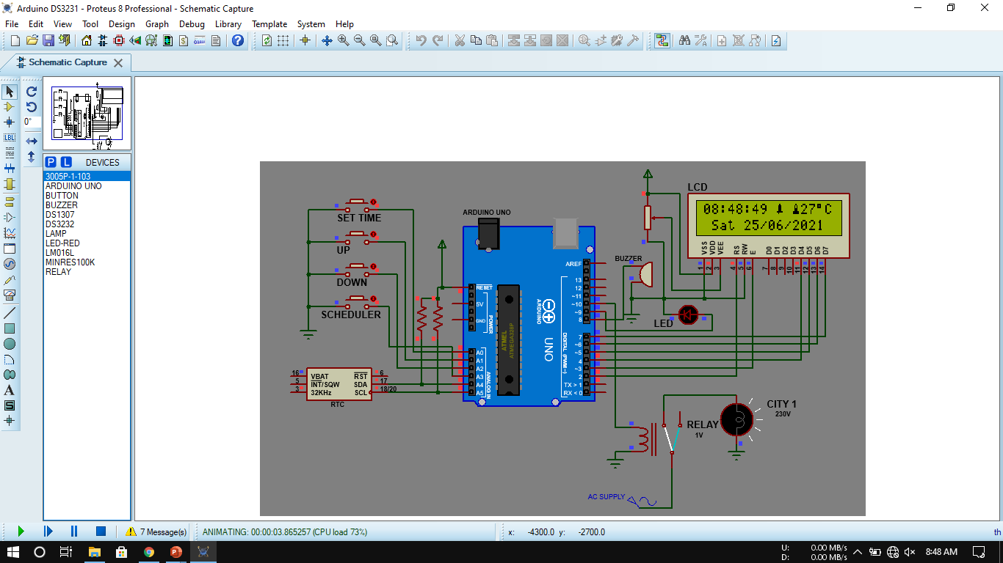

Figure 1: Simulation output

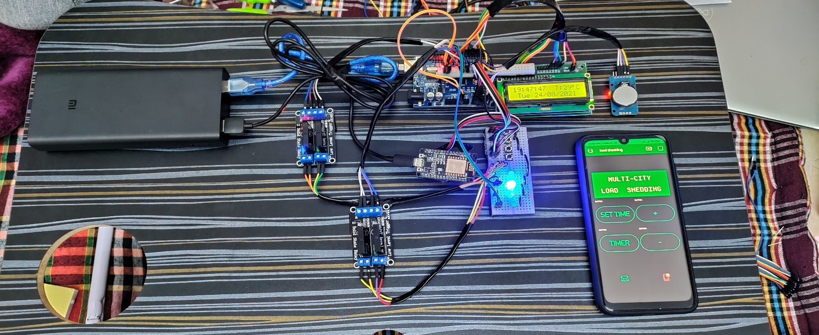

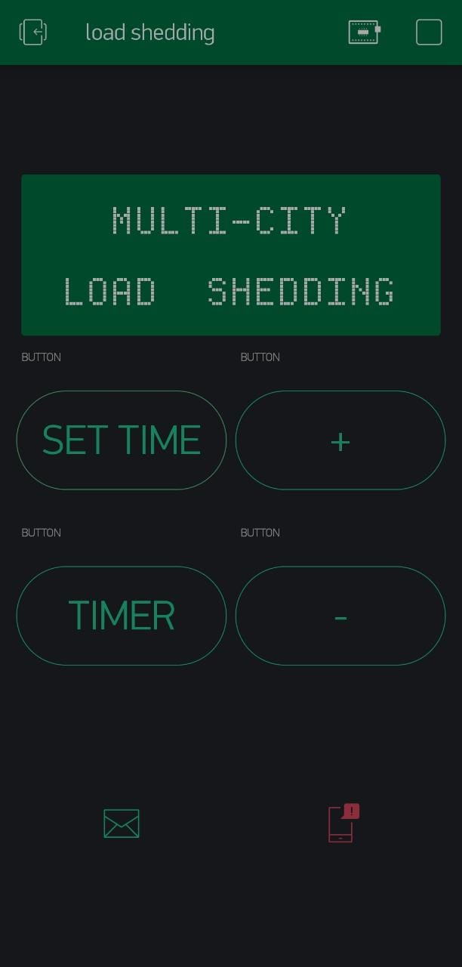

Figure 2: Hardware output

Figure : App used to control in the hardware (Blynk)

**CHAPTER 6:**

**ADVANTAGES**

* Due to automatic system the operation is reliable, fixed and accurate time of load shedding. Eliminates unnecessary load shedding.
* Fast response to disturbance.
* Display required time and place of load shedding.
* The planned schedules ensure that available capacity is shared fairly and each consumer gets power at one time or another.
* It will be well informed about the load shedding so that the consumers can schedule their work accordingly.
* It reduces the human risk and save the time by pre schedule the current and its distributions.
* Every one can get the information about the load shedding through their mobiles, or any social medias, etc.
* Proper load shedding technique also save the power and cost.

**CHAPTER 7:**

**CONCLUSION AND FUTURE WORK**

**CONCLUSION:**

From the customer point of view, we are able to see that the load shedding is a burden to the customer. After knowing the difficulties of total blackout, we have taken this project as a challenge where we schedule the load shedding process when and as required. This system manages the power in critical demand situations so that people can do their basic needs of the daily activity without any interruption due to power cut.

With the increasing power demand in the modern era, there is a significant impact on power system stability. This paper has attempted to showcase existing load shedding methods is not solitary sufficient for the modern power system, smart grid system, and power system with distributed generation.

This method helped in providing the required power to meet the necessary demands of the consumer. Thus, this project made to ensure that the system will be stable, meeting the necessity. We brought the IoT in our project for proper implementation on restriction the total usage. IoT is a developing technology which has high future scopes. With the development of technology, the present IoT technology will flourish. These improvements when applied to our project will increase its functionality.

**FUTURE WORK:**

With the improvement in technology and increase of living standards the demand for energy will always increase. Thus, the chances of supply not able to meet the demand will be prominent. Load shedding will be an ever-occurring event. The proposed project we brought forward can be improved further with the technological advancements in network. The IoT module and cost awareness system, we proposed can be integrated with smart home in future.

With better technology and advancement in the software we will be able to see further development in this project. Below are few advancements mentioned that can be added to this project in the future.

* The better method for the fault detection system to detect the location of fault area and better load monitoring can be developed.
* Notification of system failure or fault detection can be provided directly to the officials with improved network and technology.
* Better user interface and experience.
* Show the user available power and the about that needs to be shed.

**SUMMARY:**

At the end of this project work, we were able to design and develop multi city load shedding model which can be handle automatically through IoT. In the process of the design first we obtained the information about limitations of current manual load shedding technology and we worked on to improvise it through modern technology. This work also will serve stepping stone towards making digital India and also for people who wish to research more on this topic.

In this project, we review the role of IoT in the energy sector. Provision of facility for handling load shedding automatically using IoT to reduce delay and conserve time. So, using this modern technology we have designed to transform the energy sector from a central, hierarchical supply chain to a decentralized, smart and optimized system.

Energy sector are on the threshold of a new transition era, with the model power supply was made easier. The systematic approach used during each phase of the model provides a clear road map that would be of immense help to anyone carrying out research work in this area.

**CHAPTER 7:**

**REFERENCE**

1. <https://www.automationit.com/blog/36-load-shedding-design>
2. <https://www.iotforall.com/using-iot-to-reduce-the-shock-of-blackouts-and-load-shedding>
3. <https://www.semanticscholar.org/paper/IoT-based-Load-Shedding-PraveenRajR.-Narayan/226ea35c45f765a5dab903e1e553795406fd6a5f>
4. <https://www.researchgate.net/publication/319170466_Load_Shedding_and_Smart-Direct_Load_Control_Using_Internet_of_Things_in_Smart_Grid_Demand_Response_Management>
5. <https://www.google.com/url?sa=t&source=web&rct=j&url=https://www.ijtsrd.com/papers/ijtsrd18364.pdf&ved=2ahUKEwjvh9P_m6vxAhXSdCsKHQHiApYQFjAHegQIDBAC&usg=AOvVaw1_lixkiNtrOpbEGg-bhtsR&cshid=1624364442250>
6. H. Bevrani, A. G. Tikdari, and T. Hiyama, “Power System Load Shedding: Key Issues and New Perspectives” International Journal of Electrical and Computer Engineering Vol:4, No:5, 2010.
7. M.M. Hosseini-Bioki, M. Rashidinejad, A. Abdollahi, “An implementation of particle swarm optimization to evaluate optimal under-voltage load shedding in competitive electricity markets” Journal of Power Sources, 122-131, 2013.
8. Zoran Salcic , Zhenguo Li, U.D. Annakkage, Nalin Pahalawaththa, “A comparison of frequency measurement methods for underfrequency load shedding” Electric Power Systems Research, 209- 219, 1998.
9. Raghu C N, A Manjunatha, Assessing Effectiveness of Research for Load Shedding in Power System , IJECE, Vol.4, No4, 2017.
10. Renuga VERAYIAH, Azah MOHAMED, Hussain SHAREEF, Izham ZAINAL ABIDIN, “Review of Under-voltage Load Shedding Schemes in Power System Operation” PRZEGLĄD ELEKTROTECHNICZNY,2014.
11. T. Amraee, A.M. Ranjbar, B. Mozafari, N. Sadati, “An enhanced under-voltage load-shedding scheme to provide voltage stability”, Electric Power Systems Research , 1038–1046, 2007.
12. Ahmad Ahmadi, Yousef Alinejad-Beromi, “A new integer-value modelling of optimal load shedding to prevent voltage instability”, Electrical Power and Energy Systems 65 (2015) 210–219, 2015.
13. NYISO Interim Report August 14, 2003 Blackout.
14. M. K. Kirar, R. Kamdar, M. Kumar, G. Agihotri, “Load Shedding Design for An Industrial Cogeneration System”, Electrical and Electronics Engineering: An International Journal, Vol 2, No 2, May 2013.
15. M. Lu, W. A. W. Zainal Abidin, T. Masri, D. H. A. Lee, S. Chen, “ Under-Frequency Load Shedding (UFLS) Schemes – A Survey”, International Journal of Applied Engineering Research ISSN 0973-4562 Volume 11, 2016.
16. Yujin Lim a, Hak-Man Kim, “Strategic bidding using reinforcement learning for load shedding in microgrids” Computers and Electrical Engineering 40 (2014) 1439–1446, 2014.
17. M. Karimi, H. Mohamad , H. Mokhlis , A.H.A. Bakar, “Under-Frequency Load Shedding scheme for islanded distribution network connected with mini hydro” Electrical Power and Energy Systems 42 (2012) 127–138, 2012.
18. Arun Joy and D. Manivannan, “ Smart Energy Management and Scheduling using Internet of Things" Indian Journal of Science and Technology, Vol 9(48) December 2016
19. U. K. Jethwa, R. K. Bansal, N. Date and R. Vaishnav,” Comprehensive Load-Shedding System,” in IEEE Transactions on Industry Applications, vol. 46, no. 2, pp. 740-749, March-April 2010.
20. S. Suresh, R. Nagarajan, L. Sakthivel, V. Logesh, C. Mohandass, G. Tamilselvan, “Transmission Line Fault Monitoring and Identification System by Using Internet of Things", International Journal of Advanced Engineering Research and Science (IJAERS), Vol-4, Issue-4, Apr- 2017.
21. L. Angrisan, P. Arpaia, F. Bonavolonta, A. Liccardo Dip, di Ing, R. Schiano Lo Moriello, "First step towards a cost-effective lot platform for customers power consumption awareness," 2017 IEEE International Workshop on Measurement and Networking (M&N), Naples, 2017, pp. 1-5.